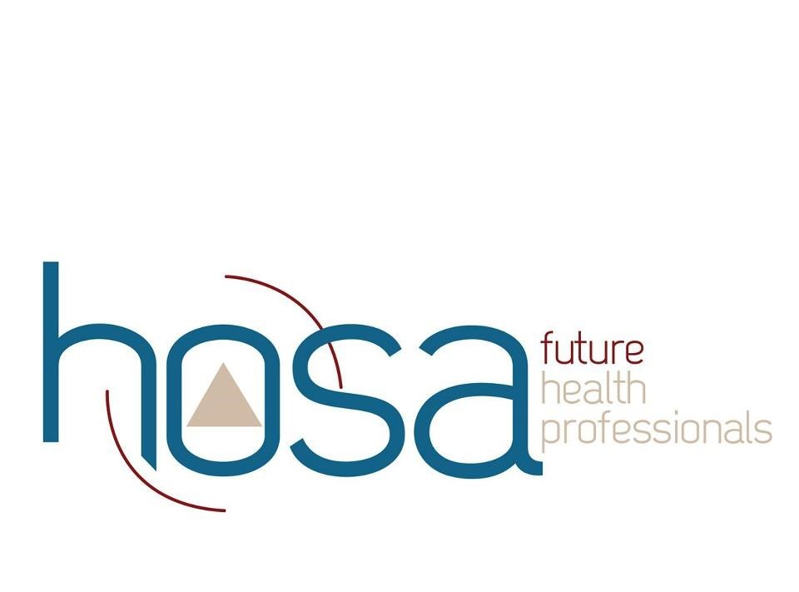

MMACHS HOSA
MERIDIAN MEDICAL ARTS CHARTER HIGH SCHOOL
“Direct Donation” Fundraiser Form/Receipt
Name: |  | Phone Number
Address:
City: | State: | Zip Code:
Donation Amount:
$25.00_____ $50.00_____ $100.00_____ $250.00 _____ $500.00_____ Other $_________

_____My employer has a Matching gift Program. Please let us know how we should proceed to maximize your donation.

Please make checks payable to MMACHS HOSA, or donate online at www.meridianmedicalartscharter.org/giving/ .

Student’s name _________________________________________________________________________

Donor’s name _________________________________________________________________________

All contributions are 100% tax deductible and 100% goes directly to MMACHS HOSA.

This form, when signed below by the Advisor or School Representative, will serve as your receipt. MMACHS HOSA is a non-profit 501(c)(3) organization.
Advisor or school representative signature: |  |  |  |  |  |  |  | Date:
If you have any questions, please contact Blake Gaudet at 2088554075 or email Gaudet.blake@westada.org. MMACHS is a non-profit school Idaho State Number: 57-1149368

